Adult Skills Fund
Free Courses for Jobs
Commissioning Plan 2026-2027

- Purpose and commissioning intent

  - As part of the Level 2 devolution deal agreed with the government, the Adult Skills Fund (ASF) and Free Courses for Jobs (FCFJ) will be fully devolved to Buchinghamshire Council from August 2026. This presents an opportunity to reshape the adult skills provision in Buckinghamshire, aligning investment with local labour market needs and strategic priorities.

  - The Adult Skills funding supported approximately 7,450 Buckinghamshire learners in 23/24. This equated to 12,400 enrolments and 11,940 starts. Around 5,300 learners participated on courses funded through the Education & Training strand (qualification based), with 2,550 taking part in Community Learning (non-accredited learning). Buckinghamshire residents are typically supported via ASF on an annual basis. Under the terms of the devolution agreement, the Council has a level of autonomy to better align ASF with local priorities, whilst recognising statutory legal entitlements including access to fully funded essential English, maths, digital and first Level 2 and Level 3 qualifications in certain circumstances. FCFJ is delivered alongside ASF for primarily fully funded Level 3 and is typically targeted at adults who do not already hold this level of qualification, or who are unemployed or earning below the low wage threshold and can support upskilling in sectors with high demand.

  - The ASF supports adults aged 19 and over in gaining essential skills for both life and work, primarily funding qualifications up to and including Level 2. A significant share of ASF is dedicated to meeting legal entitlements which include:
- English and maths up to and including Level 2 for individuals aged 19 and over who have not previously achieved a GCSE grade A* - C or grade 4 or higher, and/or have been assessed as having an existing skill level lower than grade 4 (even if they have previously achieved a GCSE or equivalent qualification in English or maths)
- First full qualification at Level 2 for individuals aged 19 to 23 and/or
- First full qualification at Level 3 for individuals aged 19 to 23
- EDSQ or digital FSQ up to and including Level 1 for individuals 19 and over who have digital skills assessed below level 1

  - Tailored Learning provides flexible, non-regulated opportunities aimed at widening participation and delivering broader outcomes, with a strong focus on supporting those who are disadvantaged or least likely to engage in learning. Tailored Learning provision supports:
- Engaging and/or building confidence
- Preparation for further learning and/or employment
- Improving essential skills (English, ESOL, maths, digital)
- Equipping parents/carers to support children’s learning
- Health and well-being and developing stronger communities

  - Additionally, there is ringfenced ASF for Free Courses for Jobs (FCFJ), enabling individuals without a Level 3 qualification to get one fully funded. It also supports those who already hold a Level 3 but earn below the earnings threshold. The Council has raised the earning threshold for fully funded Level 3 provision to £31,427 to increase eligibility for accessing fully funded training.

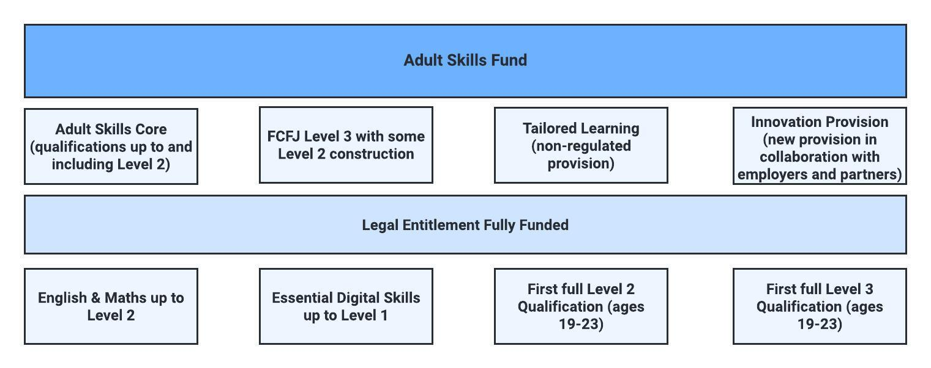

  - For Year 1 (2026/27), the Council’s commissioning approach will prioritise stability and continuity of good-quality provision, while putting in place the governance, data systems, and market routes needed to move to a more fully evidence-led model from Year 2.

  - This plan sets out how Buckinghamshire will allocate funding, procure provision and manage cross-border learning for Buckinghamshire residents and learning providers and assure quality and value for money across 2026/2027.

- Strategic outcomes for 2026/2027

  - Our approach is designed to enable Buckinghamshire residents to gain the skills and qualifications needed for meaningful, sustained and relevant employment or to progress to further learning.

  - Support priority sectors as identified in Buckinghamshire's Local Skills Improvement Plan (LSIP) and address skills gaps in areas such as construction, engineering, health and social care, digital skills for work and AI, work readiness and leadership & management.

  - Improved progression and participation for residents with barriers to learning/employment and ensure that all residents regardless of background/circumstance can access opportunities to upskill and progress.

  - Clear routes to skills acquisition and jobs.

  - Value for money and auditable spend with payments linked to actual delivery and performance oversight.

- Funding and allocation model 2026/2027

Commissioning Route | Estimated Value (£)
Grant-Funded Buckinghamshire Providers | 4,393,670
Grant-Funded Out of County Providers | 370,450
Contract for Services Providers | 637,678
Management/Admin Fee | 500,240
SWAPs | 69,508
Additional FCFJ Engineering allocation | 69,945
TOTAL | 6,041,491
DWP direct funding for continuing learners | 185,087

  - As per the Buckinghamshire Council ASF Strategic Skills Plan, the commissioning strategy combines funding agreements with grant funded providers with targeted procurement.

  - Two grant-funded providers based in Buckinghamshire (with existing DfE agreements) will enter a 1-year delivery agreement with Buckinghamshire Council. As part of these agreements each provider will be required to submit a delivery plan demonstrating how their provision aligns with Buckinghamshire priorities, including disadvantaged areas, target groups and key priority sectors and how they will work collaboratively across the county.

  - Grants will be allocated to the two eligible providers based on the proportion of 2024/2025 funding that was used to deliver provision to Buckinghamshire residents. Grant Agreements will be issued for one year (August 2026 to July 2027) with the option to extend for a further year (to July 2028), subject to provider performance and funding availability. Buckinghamshire Council’s approach in Year 1 of devolution is deliberately intended to mirror the current DWP arrangements so that we can ensure smooth transition of current providers and assess their delivery capacity and quality.

  - Only one grant funded provider receives innovative funding from the DfE. Therefore, in line with our mirrored Year 1 approach, we will continue this funding for that provider only, to support innovative delivery in collaboration with Buckinghamshire employers.

  - Several providers located outside Buckinghamshire that have demonstrated significant delivery of ASF provision to Buckinghamshire residents, and where there is evidenced demand from Buckinghamshire learners through DfE data, will enter into a one-year out-of-county grant agreement.
  - Out-of-county grant funding cannot be used to fund English and maths learning aims. Tailored learning provision and subcontracting arrangements will not be eligible for funding under this agreement unless explicitly agreed by the Council and set out within the terms of the agreement.

  - The remaining Adult Skills Fund is strategically allocated through targeted procurement to address specific gas and priorities. As per Buckinghamshire Council Adult Skills Fund, Strategic Skills Plan, it is intended that the number of procured providers will be reduced significantly. This will be achieved by applying minimum contract values.

  - The procurement activity will be governed by Buckinghamshire Council’s Contract Procedure Rules (CPRs) and associated governance frameworks. Buckinghamshire Council will use the Crown Commercial Service - Adult Skills and Learning Dynamic Purchasing System (DPS) Framework to shortlist eligible providers. Providers must demonstrate an established, place-based delivery model that supports the strategic ambitions set out in Buckinghamshire Council’s ASF Strategic Skills Plan and Skills and Employment Strategy.

  - Contracts for service delivery will be issued for 1 year (August 2026 to July 2027) with the option to extend for a further year. The extension will be subject to provider performance, skills policy and funding availability.

  - The following areas have been prioritised due to their cross-cutting strategic importance as identified within the LSIP in addition to key priorities established during the research and consultation stages of developing this plan. Buckinghamshire Council reserves the right to respond flexibly to changing needs and ensure the most appropriate alignment of ASF and FCFJ allocations.

Priority | Description | Provision Aligned to Subject Sector Areas
Construction | Qualifications up to and including Level 2 and Level 3 | SSA 5 - Construction, Planning and the Built Environment: 5.2 - Building and construction
English & Maths | Qualifications up to and including Level 2 | SSA 12 - Languages, Literature and Culture: 12.1 - Languages, literature and culture of the British Isles;  SSA 2 - Science and Mathematics: 2.2 - Mathematics and statistics
Digital skills for work & AI | Qualifications up to and including Level 2 and Level 3 | SSA 6 - Digital Technology: 6.1 - Digital technology (practitioners); 6.2 - Digital technology (users)
ESOL | Qualifications up to and including Level 2 | SSA 14 Preparation for work and life: 14.1 Foundations for learning and life;
Health & Social Care | Qualifications up to and including Level 2 and Level 3 | SSA 1 - Health, Public services and care: 1.3 - Health and social care; 1.5 - Child development and well being
Leadership & Management | Level 3 qualifications | SSA 15 - Business, Administration and Law: 15.2 – Administration; 15.3 - Business management
Net Zero / Green Skills | Qualifications up to and including Level 2 and Level 3 | Cross Cutting themes: 3.4 - Environmental conservation; 4.1 – Engineering; 4.2 - Manufacturing technologies; 5.2 - Building and construction
Warehousing and distribution | Qualifications up to and including Level 2 and Level 3 | SSA 7 - Retail and Commercial Enterprise: 7.2 - Warehousing and distribution
Work Readiness | Qualifications up to and including Level 2 | SSA 14 - Preparation for Life and Work: 14.2 - Preparation for work

- Out of County learner-led process

  - A limited allocation of additional funding will be available to support eligible Buckinghamshire residents who wish to study outside the county with a learning provider that is not funded through one of the Council’s Out of County Grant Agreements. This funding is discretionary and is not an automatic entitlement. Applications will be assessed individually in accordance with the Council’s Cross-Border Learning Policy and will be subject to confirmation of learner eligibility, the suitability and necessity of the proposed provision, the absence of a suitable and accessible local alternative, provider assurance requirements and value for money. Funding will be capped at £6,000 per learner in each academic year and will be subject to prior written approval by the Council. Approval will depend on the availability of funding, and the Council may refuse, limit or prioritise applications where demand exceeds the available budget. Funding will not be approved retrospectively.

- Payment and performance rules

  - Grand-funded providers will be given, in advance of the start of the Grant Agreement, an agreed Financial Forecast and Payment Plan.

  - The Council will pay providers operating under a Contract for services based on actual delivery per month in arrears.

  - For non-grant providers, Buckinghamshire Council will remove the approach that allows 100% for 97% performance, ensuring the Council only pays for delivery that has taken place.

  - Buckinghamshire Council will operate a year-end redistribution model which will enable any underspend across the delivery aspects of the programme to be redistributed to grant-funded providers that have overperformed. This approach replaces the DfE 10% over-performance at risk model.

- Performance, Quality and Compliance requirements

The Provider will be required to comply with Buckinghamshire Council’s Provider Documents which cover policies and procedures in relation to:

- ASF Provider Performance Management Framework
- ASF Audit Plan
- ASF Subcontracting Policy
- ASF Cross-Border Learning Policy
- ASF Complaints and Investigations Procedure
- ASF Strategic Skills Plan

