5.1 Process Description
Aum Crematorium by Anoopam Mission
The Lea, Western Avenue, Denham, Uxbridge, Middx, UB9 4NA
Description of the Proposed Installation and Activities

The site location for Aum Crematorium conforms with the requirements of the Cremation Act 1902 Section 5 in that the location of the crematorium building does not lie any nearer than 200 yards (181.36 meters) to any dwelling house nor within 50 yards (45.34 meters) of any public highway.
The cremation of human remains constitutes the burning of a human body contained within a wooden coffin, or occasionally a coffin made of other materials, which is presented at the crematorium for cremation by a Funeral Director. Prior to cremation the Cremation Authority insists on receiving a signed declaration from the Funeral Director to acknowledge their observance of the ‘Instructions to Funeral Director’ regarding the coffin construction, clothing and coffin content. Instructions to Funeral Directors, formulated by the Federation of Burial and Cremation Authorities, conform to the requirements of PG5/2 (25) Crematoria: best available techniques (BAT).
(Appendix B2.1a ‘Instructions to Funeral Directors’)
The Cremation Authority will install one Facultative Technologies FT4 cremator fuelled by liquified petroleum gas. The cremator and flue gas treatment plant for mercury abatement fully comply with the requirements of PG5/2 (25) Crematoria: emissions limits, monitoring and other provisions, Table 6 (Appendix B2.1b FT4 brochure and Appendix B2.1C FGT brochure).
At the commencement of each funeral service, the coffin is received onto the catafalque within the Chapel area of the crematorium. (Appendix Aum 01_L(0)2000Ground Floor flow diagram - Arrow A)
After the service, the coffin is moved from the catafalque to the crematory via the transfer room on a hydraulic trolley. (Appendix Ground Aum 01_L (0)2000Ground Floor flow diagram - Arrow B). The coffin is loaded onto the automatic charging bier; (Appendix Ground Aum 01_L (0)2000Ground Floor flow diagram – Arrow C). The cremators are then charged using the automatic loader (Appendix FTL4FTL8 loaders Uk V1.0 O&M)
If the cremator’s is already in use, the coffin loaded on the storage rack pending the completion of the previous cremation. The bier is then transferred back to the Transfer corridor. (Appendix Ground Aum 01_L (0)2000Ground Floor flow diagram - Arrow B)

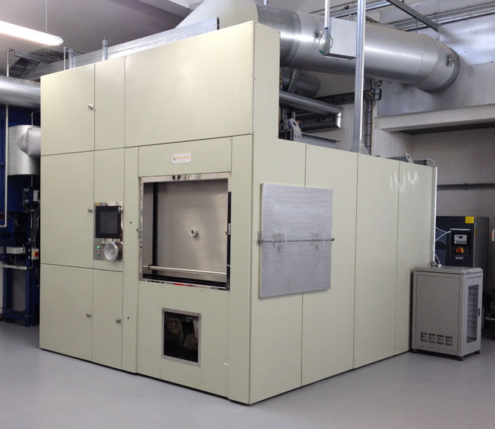
CREMATOR
The cremator comprises of a primary chamber into which the coffin is inserted. through an actuated charge door and within which the primary combustion takes place.
The charging door is interlocked to prevent the introduction of a coffin into the primary combustion zone unless the temperature in the secondary combustion zone exceeds 1073K (800˚C).
The primary chamber hearth is flat and contains no openings, so that all materials are retained for combustion, and avoids the by-passing of flue gases. The waste gas from this primary combustion phase exits the primary chamber via transfer ports and enters the secondary combustion chamber in which the gas phase combustion takes place. To be complaint with Process Guidance Notes PG5/2 (25) the secondary chamber maintains the flue gas combustion temperature at 800˚C minimum, including mercury abatement with a minimum gas resistance time of 2 seconds during operation, and with an oxygen concentration of minimum 6% average measured wet or dry, and minimum 3%.
Operating condition request to change: In Table 2 and subsequent paragraph of Crematoria: emission limits and monitoring in the PG5/2 (25) guidance, there is scope for the EHO to authorise alternative operating conditions as long as emission levels are maintained. As cremator operators we are always seeking to reduce our gas consumption and would like to propose the following when operating on abatement:
- Allowing the secondary chamber temperature to drop to a minimum of 750°C, while still maintaining an average temperature of 800°C across the cremation cycle.
- Measuring the temperature at the entry to the secondary chamber, rather than at the exit.
- Allow the residence time to drop below 2 seconds
In collaboration with the manufacturer (FT), we believe emission levels can still be achieved operating this way through abatement and estimate this could reduce gas usage by up to 20%. We also are aware that a similar approach has been accepted at Margam Crematorium in Wales (Appendix B2.1h Margam varied permit and Appendix B2.1j an emission test to prove emission levels achieved, completed in the trial phase before the permit was varied).
In line with PG5/2 (25) guidance, should this arrangement be accepted, we would also undertake annual dioxin testing rather than 3 yearly.
We welcome the council’s thoughts on allowing this approach within the new permit.
To achieve the Nox levels with Crematoria: emissions limits, monitoring and other provisions, Table 6, a Facultative Denox system will be fitted which injects a mist or proprietary urea solution into the gas stream within the secondary chamber. Use of this system has shown that a 65% reduction or Nox emissions is achievable.
The cremator will have an Automatic Process Control System, which supervises the operation of the cremator and a combustion process based upon a Programable Logic Controller with dedicated operating software. An automatic Data Logging System which stores operational information and cremation data is used to generate reports in a format fully complaint with PG5/2 (12) given no agreed format was issued with PG5/2 (25), this will be changed if updated.
An internet Broadband link will allow Remote Technical Support and enable technicians to remotely monitor cremator performance and to provide online fault diagnosis.
FLUE GAS TREATMENT
Hot gasses leaving the cremator are cooled to around 120˚C by passing through a flue gas cooler (E) filled with a glycol/water mixture which is continuously circulated through an air blast cooler (F) to dissipate excess heat to atmosphere.
Activated carbon (I) is dosed into the cooled gas stream which absorbs mercury vapour and is then captured by the bag filter (J) forming a filter cake.
An automatic compressed air system for cleaning the fabric filter ensures there is sufficient additive on the filter, whilst ensuring the gasses pass freely through the filter.
Spent reagent is collected in dedicated drums (K) which are sealed and transported to a specialist disposal and recycling centre under license.
An ID fan (M) creates the required suction to draw the cleaned gas through the filter and finally through the stack (N).

REAGENT DOSING STATION
The pre-mixed chemical reagent ‘Factivate’ is supplied in easily manageable sealed 15kg containers. The reagent is easily introduced into the automatic dosing station by inserting the closed container of reagent via the dedicated door which is then closed and sealed before the reagent is introduced, thus ensuring the automatic addition of regent under controlled, clean and safe conditions.
Under fully controlled conditions the reagent is fed via a dosing screw into the gas stream and filtration system into the required amount necessary to ensure compliance with current emissions regulations.

CONTINUOUS EMMISIONS MONITORING SYSTEMS
- A Fuji ZRJ Multi Gas analyser will provide continuous qualitative monitoring of Carbon Monoxide, and the data will be acquired at 15 second intervals or less, measured downstream from the abatement system which is where any remaining pollutant would need to be identified before release to atmosphere.
- A PCME will continuously monitor particulates, and reference levels will be set upon commissioning to provide a filter leak monitor (Gross filter failure detection).

CREMATED REMAINS and METALS
At the end of each cremation cycle, when calcination is complete as required by PG5/2 (25) and the Code of Cremation Practice, the hearth is raked to move the cremated remains through an integral ash chute into the refractory sump. Here the remains are air cooled for one hour prior to removal in a stainless-steel container. The cremator is now ready for the next cremation. (Appendix B2.1e Code of Cremation Practice)
The cremated remains are transferred from the cremator in a covered container, thus avoiding any particulate matter escaping into the atmosphere, and placed directly into the Facultative High Speed Cremulator in the Ash Transfer Room. (Appendix B1.1d Floor Plan)
The cremated remains are reduced to a fine granular consistency in the High Speed Cremulator which automatically separates any metal residues and deposits them into an empty container and places the resultant ashes directly into a temporary storage container.
Should the cremated remains need to be transferred from the temporary storage container to another urn or casket, then this is carried out in the cremated remains Transfer Cabinet.

The High Speed Cremulator and Transfer Cabinet both have an integrated dust suppression system with high efficiency air filter, thus preventing any escape of particulate matter. (Appendix B2.1f Cremulator brochure and Appendix B2.1g Transfer Cabinet Brochure).

METAL RESIDUES
The metal residues which result from the cremation process are separated in orthopaedic implants, nonferrous metals, and ferrous metals such as pins and nails (required for the safe construction of the coffin) and placed within designated bins.
All metals are collected by a registered waste company for recycling, and the orthopaedic implants are recycled into an end product which is unrecognisable as an implant.
Foreseeable Emissions
All foreseeable emissions to atmosphere during the cremation process, including start up and shut down are detailed and quantified in the answer to B3.1a.

